Architecture & Acoustics: An improved design process by means of wave-based virtual acoustics
Finnur Pind, industrial PhD student at Henning Larsen & Technical University of Denmark. fpin@henninglarsen.com.

Motivation and background
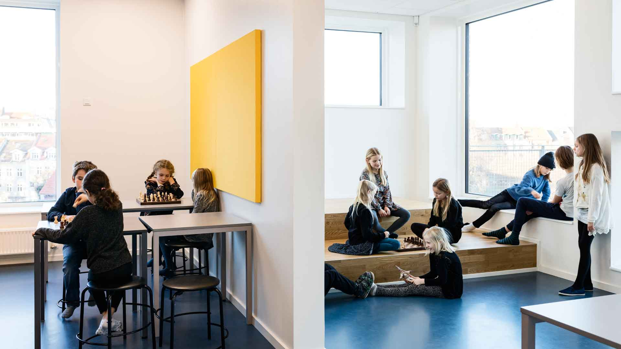
The modern workplace is changing rapidly, largely due to digitalization. Flexible, open and undefined workspaces are becoming the norm, where the goal is to promote social interaction and knowledge sharing, which is considered the key to success in many businesses. A similar trend is seen in the educational world, where large open spaces which serve a multitude of functions and different scenarios, are starting to replace the traditional classroom. These types of spaces are challenging from an acoustical point of view, and quality of the soundscape in these flexible environments is critical to their success [1]. It is therefore crucial that the acoustical design is tightly integrated into the architectural design, from the earliest design stages and throughout the entire process. The acoustics should become a design driver, influencing the geometric layout of the building, the space planning and the interior design.
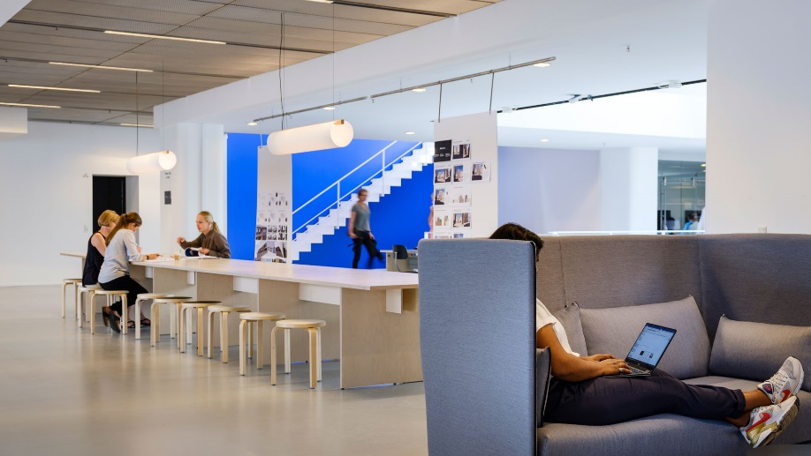
This calls for a new approach for designing room acoustics and architecture, where lighting, soundscape, furnishing, space planning, materials and function are combined into a dynamic, holistic and immersive virtual 3D experience, mimicking the real usage of the space in question. This allows for a truly informed decision making process, both for the designers and for the clients, developers and users, who often (understandably) have limited understanding of acoustics and can therefore benefit from an intuitive way of assessing the quality of a design. | 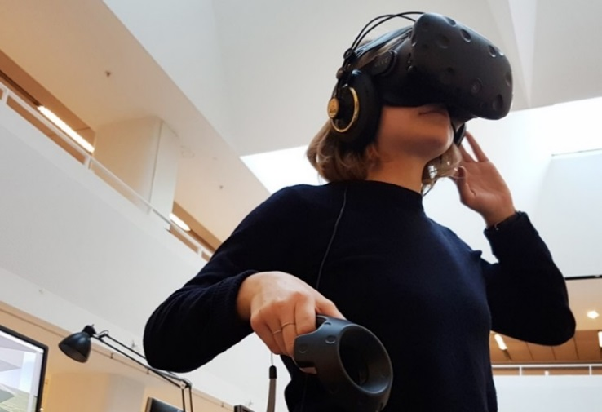

Our solution
We are developing a new architectural acoustics design process, rooted in new simulation technology, in an effort to address the above-mentioned issues. The main features of our new approach are:
- A simulation algorithm which is based on highly efficient wave-based technology, allowing for high accuracy and realism in all sizes and types of spaces, within practical time constraints. Wave-based methods are essential for creating realistic virtual acoustics, but have yet to find their way into practical usage because state of the art methods are still considered too computationally intensive [2].
- A swift workflow, allowing rapid feedback and interplay between architecture and acoustics. This is due to the simulation algorithm being mesh-based, meaning that it can easily import and analyze complex architectural models, instead of relying on simplified acoustic models which must be constructed separately.
- A coupling between the simulation algorithm and VR technology, allowing users to easily explore and investigate different acoustical designs in a holistic and immersive manner under dynamic conditions [3].
The core research focus is the development of the wave-based algorithm. Here we are applying a new mathematical approach based on a high-order spectral element method (SEM), which is considerably more efficient than the commonly used linear finite element method (FEM), because it can make use of a much coarser mesh of the domain without losing accuracy. Our findings show that our method is somewhere in the range of 100.000 to 10.000.000 times faster than the linear FEM (case dependent), which brings the simulation time down from days/hours to a few minutes! For more details on the algorithm’s abilities, see our recently submitted journal paper manuscript (currently under review) [4].
Current research topics include accurate modelling of boundary conditions (walls, ceilings, floors, furniture, acoustic absorbers etc.) and complex geometries within the SEM framework. Furthermore, we are looking into advanced computing aspects such as massive parallelism and cloud computing for improved efficiency. Finally, we are developing a novel 3D sound approach based on energy fluxes for accurate localization within the virtual space.
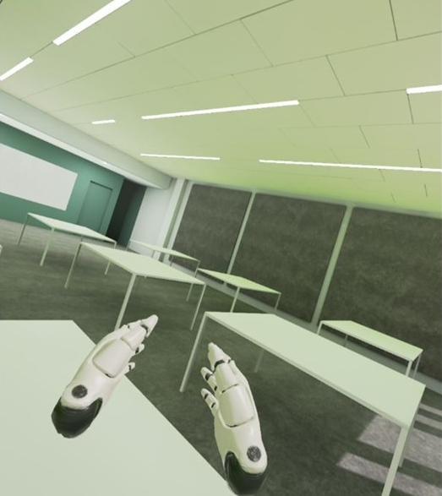
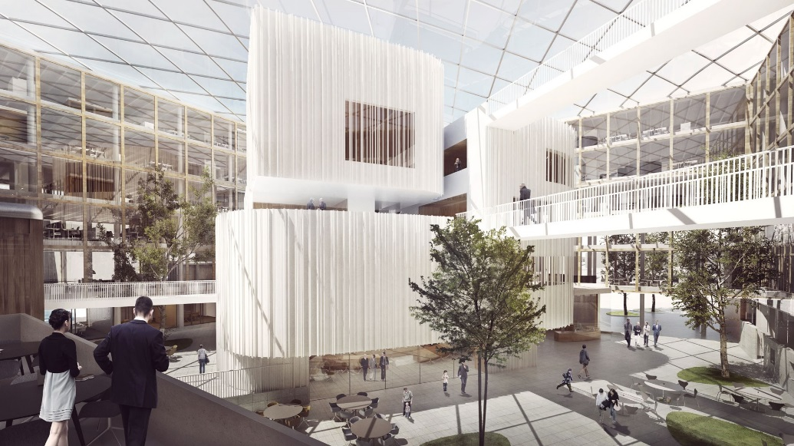
A couple of real-life case studies in Henning Larsen have been set up, using the tools we are developing. VR mockups of classrooms in the new Cincinnati School of Business and of an atrium space in the new Uppsala City Hall were used to help both the clients and the designers make informed decisions about the acoustical design, with great success.

The primary motivation for our work relates to the building industry, but the technology we are developing can certainly be used in other settings too, such as in the computer game industry, VR, hearing research, film and music, anywhere were realistic virtual acoustics are needed.

Research Partners
Assoc. Prof. Cheol-Ho Jeong, Acoustic Technology, Dept. of Electrical Engineering, DTU
Assoc. Prof. Allan P. Engsig-Karup, Scientific Computing, Dept. of Applied Mathematics and Computer Science, DTU
Jakob Strømann-Andersen, Partner, Head of Sustainability Engineering, Henning Larsen
Prof. Jan Hesthaven, Chair of Computational Mathematics and Simulation Science, EPFL

References
[1] “A Briefing on Global Workplace Strategy, Management, Satisfaction & Effectiveness”. Leesman Review, Issue 17, 3. 2015.
[2] M. Vorlander. “Computer simulations in room acoustics: Concepts and uncertainties”. The Journal of the Acoustical Society of America, 133, 1203–1213. 2013.
[3] F. Pind, C.-H. Jeong, H. S. Llopis, K. Kosikowski, J. Strømann-Andersen. ”Acoustic virtual reality – methods and challenges”, Proceedings of the 2018 Baltic-Nordic Acoustic meeting”, 2018.
[4] F. Pind, M. S. Mejling, A. P. Engsig-Karup, C.-H. Jeong, J. Strømann-Andersen. ”Room acoustic simulations using the spectral element method”. The Journal of the Acoustical Society of America. Under review. 2018.

