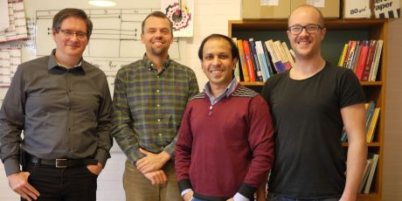

CAMM presentation day

Friday 12th December, 13-16.30

DTU Mechanical Engineering, Building 427, room 119, DTU

Program:
13.00-13.15: Coffee & cake
13.15-13.30: Introduction - Jakob Søndergaard Jensen
13.30-13.50: Analysis and optimization of acoustic-mechanical interaction problems - Junghwan Kook
13.50-14.10: Niels Aage – new CAMM faculty at DTU MEK / Solid Mechanics
14.10-14.30: Coffee
14.30-14.50: Vicente Cutanda Henríquez – new CAMM faculty at DTU Elektro / Acoustic Technology
14.50-15.10: Aminul Islam – new CAMM faculty at DTU MEK / Manufacturing Engineering
15.10-15.30: Snacks & refreshments
15.30-16.30: Tour of the facilities at plastic lab & fablab

Please sign up with CAMM-coordinator Nadia Larsen (njl@elektro.dtu.dk) December 4th at the latest.
Best regards
Jakob Søndergaard Jensen
Head of CAMM

